**Summary Report #1**Andrew Randall, Fan Kang, Lovdeep Singh, & Maral Mohaghegi

**Progress**

Our group started the project by creating a schedule for specific milestones that need to be met during the six-week design period. This schedule serves as a guide for the team to follow the design process to reach a favourable outcome. We then divided the tesseract challenge into multiple smaller steps that could each be addressed and tested individually. This break down allowed the group to set goals on which parts of the challenge were of higher priority and which ones needed to be dealt with first, resulting in a much more detailed project completion schedule. The break down of the design problem as discussed by our group are as follows:

1. Locate the cube
2. Pick up the cube
3. Locate the pyramid that is emitting the correct signal
4. Pick up pyramid
5. Place pyramid over cube

In addition to breaking down the design challenge the group also discussed areas of concern in each of the steps to ensure that these concerns were taken into consideration as possible solutions were discussed.

After the details of the challenge were thoroughly discussed and fully understood, the group started the concept generation process. We created a shared document of all the possible parts that might be useful for the completion of any steps of the challenge. This document includes the names of the products, the cost, and possible sources they could be acquired from.

Our group decided to proceed with individual brainstorming as well which resulted in multiple designs for picking up the pyramid and the cube. Each member modeled their designs in SolidWorks and Autodesk Inventor (for VEX CAD library support) so the designs could be fully evaluated by the group. A number of these designs are presented in the Appendix.

**Prognosis**

Prototyping our proposed design concepts with VEX parts for the intake mechanism for the pyramid and cube, drivetrain, and arms will give us more insight into sensor selection and will verify a more sophisticated design. The roller design (see **Figure 1:** Roller Intake Mechanism CAD) at a 30 degree angle based on rollers in factory production lines will verify if the pyramid and cube can both be manipulated with one intake mechanism, or if separate claw-type mechanisms are needed. The four-wheel drive train proposed will be elevated >1 inch through the use of 4-inch wheels to be able to drive over the conduits in the power plant. A holonomic drive (see **Figure 2:** Mecanum Drive CAD) is preferred for the ability to drive in all directions without turning to best locate the cube, and will be experimented with to support this decision. If a need for a lift is found, it is suggested the lift be a linear lift to best maneuver the tesseracts and Pyramids autonomously, or a simple non-linear lift design for reliability (see **Figure 3:** Simple Lift Designs CAD). We will likely use the Arduino-compatible STM32 Cortex-M4 microcontrollers for this project for its stronger computing power, to process information from the sensors quickly and help us complete the task in under 3 minutes.

**Plan**

In the following weeks our group plans on continuing the concept generation and concept selection process for different mechanisms on the robot. We also plan on working on the software side of the project after the sensors being used to locate the cube and pyramid are selected. Our group is looking to ensure that enough time is allotted for each mechanism on the robot to go through at least two iterations. We plan to build our first prototypes using VEX Robotics parts to test our proposed designs and concepts, after which we will design the accepted design parts to be laser cut for the final prototype. Breaking down the design challenge into multiple smaller parts will allow the group to design, build, and iterate different mechanisms with more success without the need to hold off testing until the entire robot is completed.

**Appendix**

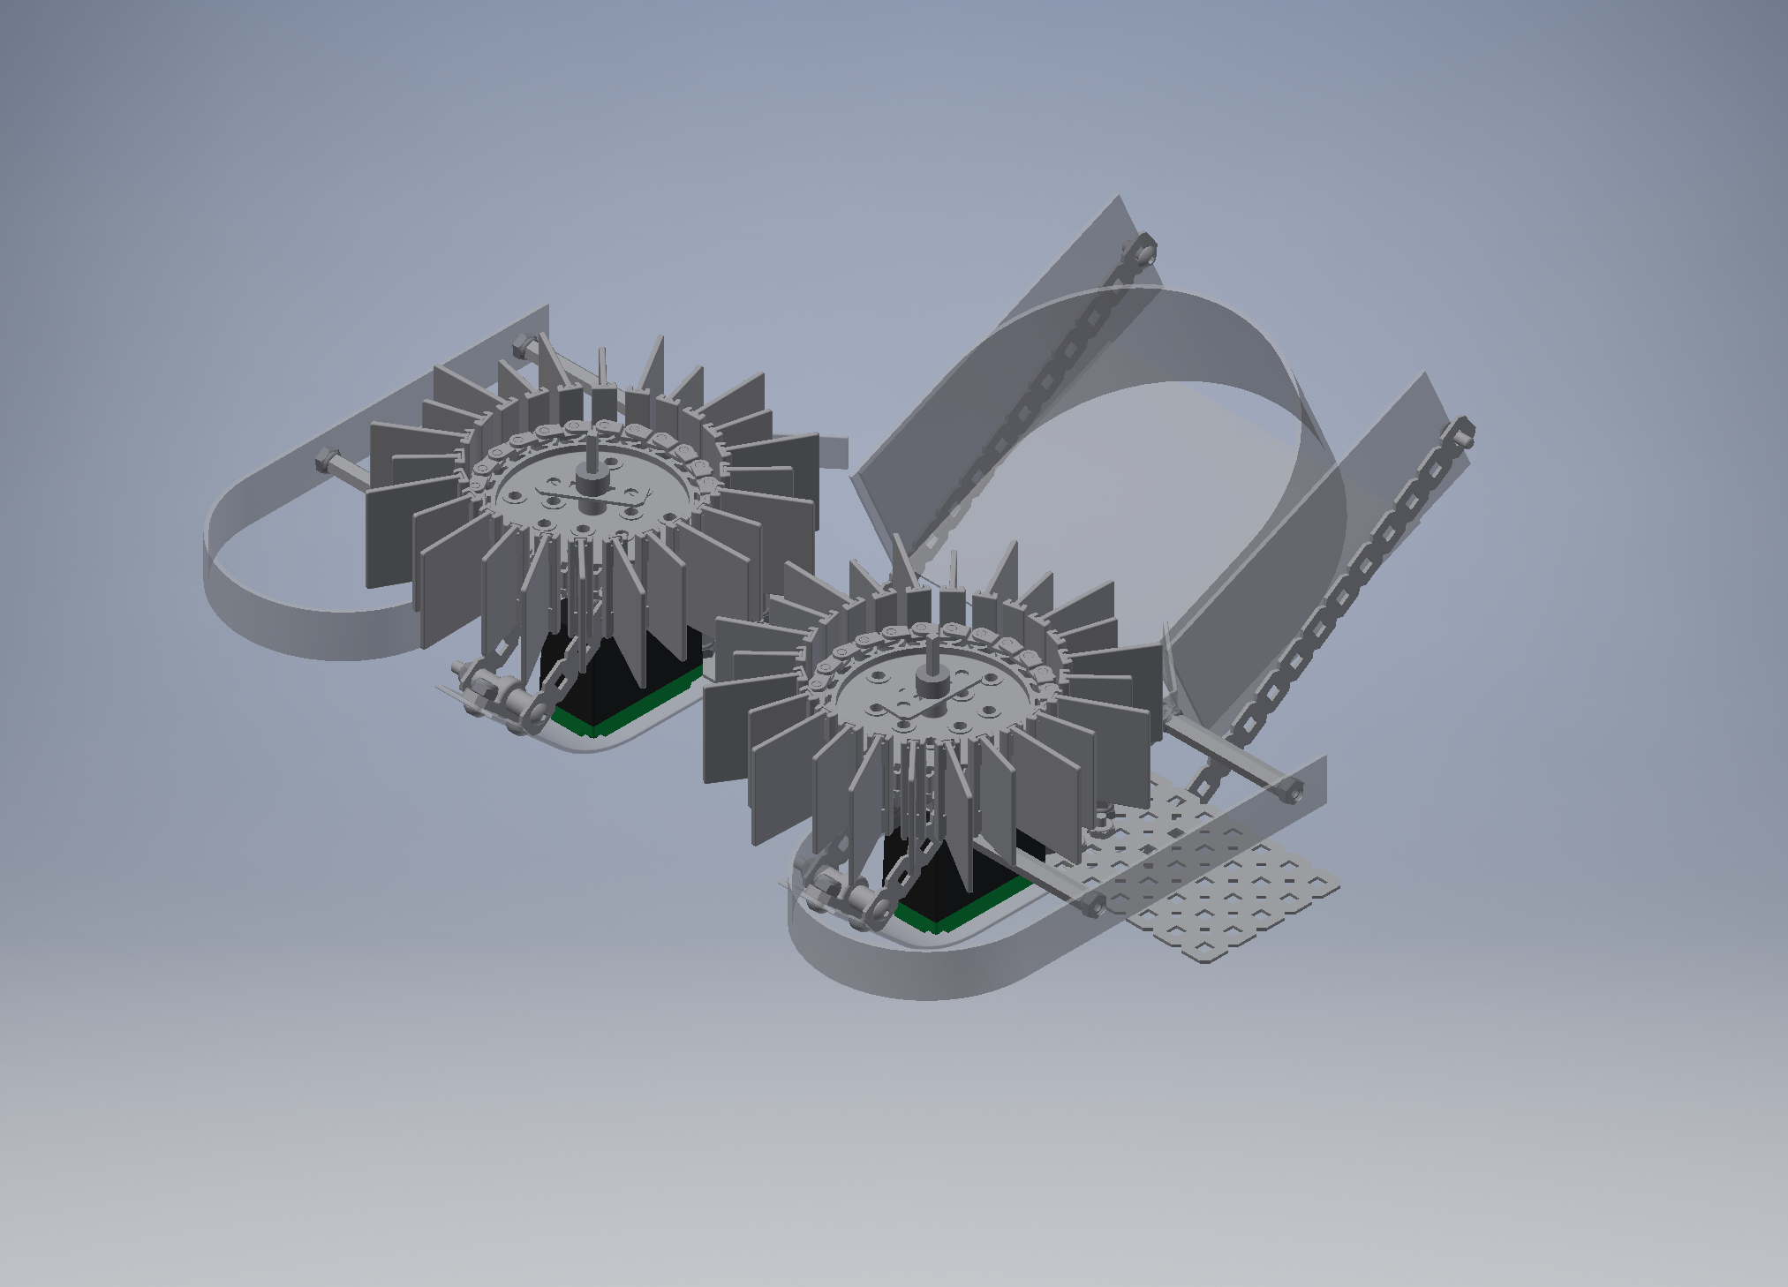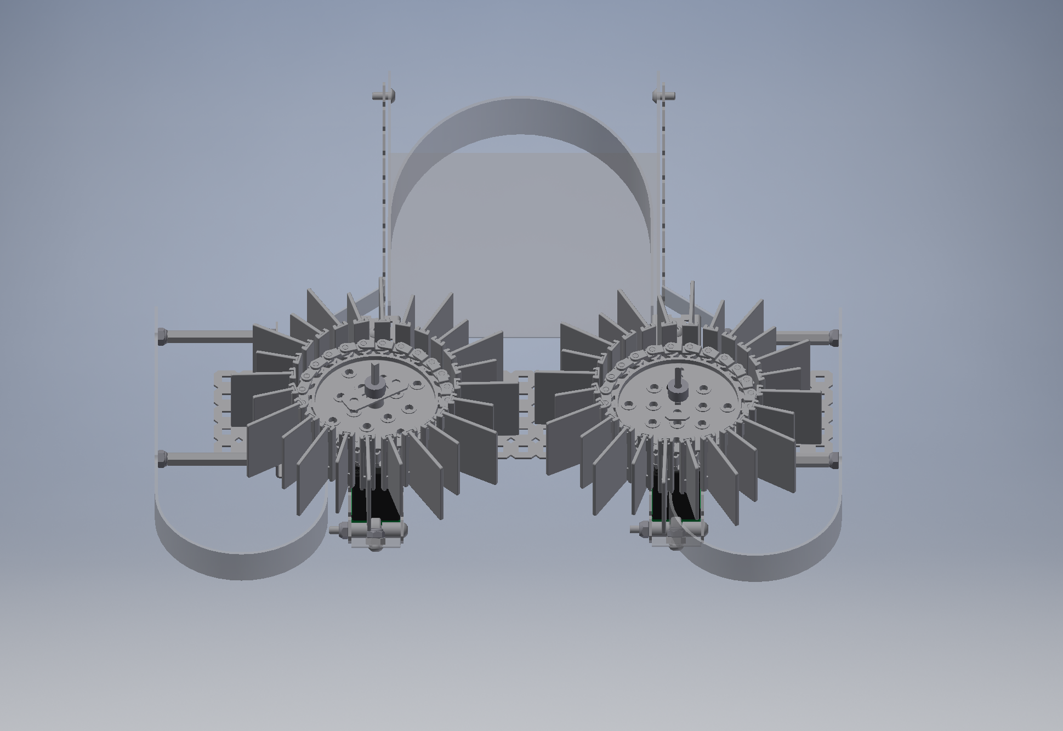

**Figure 1:** Roller Intake Mechanism CAD

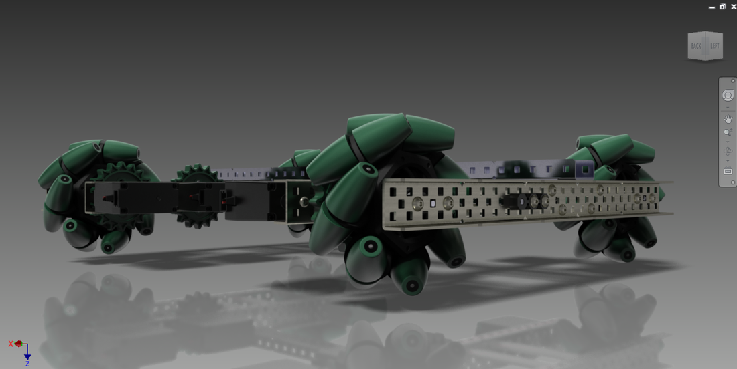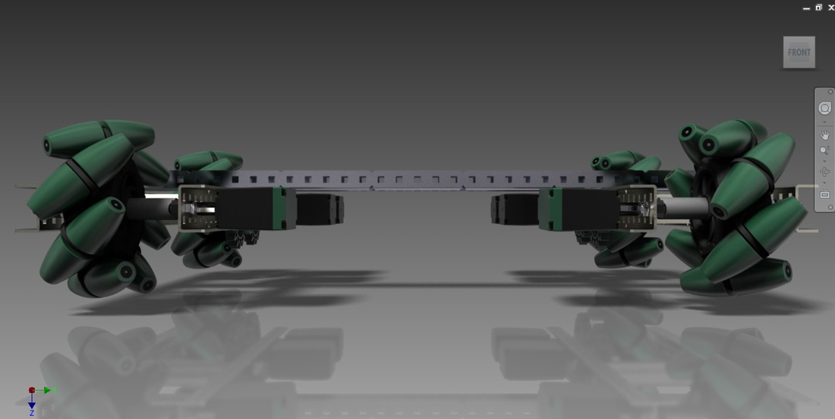

**Figure 2:** Mecanum Drive CAD

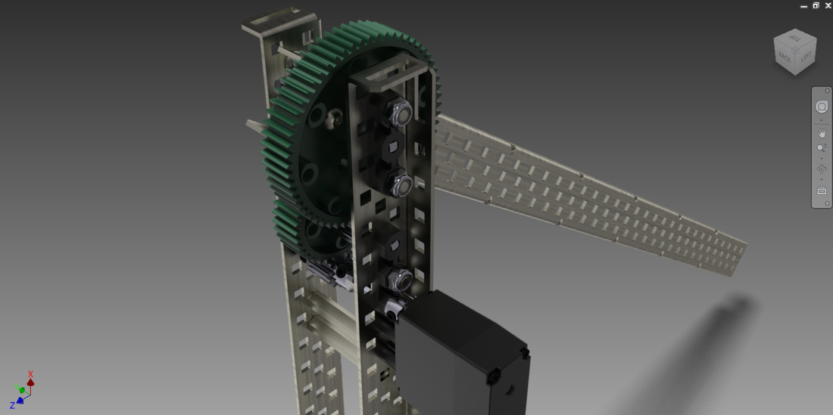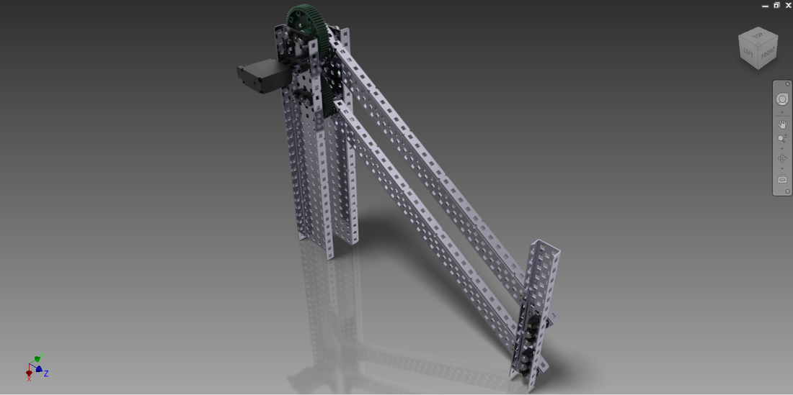

**Figure 3:** Simple Lift Designs CAD